# Unit 4. Packages, The Applet Classes

| 4.1. Package Naming, Type Imports  4.2. Package Access, Package Contents  4.3. Package Object and Specification  4.4. Applet Basics, Applet Architecture  4.5. Applet skeleton, Applet Display Methods  4.6. HTML APPLET Tag (<APPLET>), Applet Viewer  4.7. Passing Parameters to Applets |
| --- |

* **What is a package :**
* Java package is a collection of similar type of classes,interfaces and sub-packages.
* A package can be defined as a grouping of related types(classes,interfaces etc.) Providing access protection and namespace management.
* A package is a container for classes that is used to categorize the class namespace.

**4.1. Package Naming, Type Import**

* **Package naming / name convention :**

**4.2. Package Access, Package Contents**

**4.3. Package Object and Specification**

**4.4. Applet Basics, Applet Architecture**

* **Java Applet :**
* An applet is a java program that runs in web browser.
* An applet is a java class that extends the **java.applet.Applet** class.
* Applet are designed to be embedded within the HTML page using **APPLET** or **OBJECT** tag and hosted on a web browser.
* An applet are used to make website more dynamic and entertaining.
* Output of an applet is handled with various **AWT** methods,such as drawString,drawRect and so on.
* JVM is required to view an applet.
* Applet have strict security rules that are enforced by the web browser.
* **Public void paint( )** method is used in place of **main( )** method.
* **Applet architecture :**

**✓ Runtime architecture for java programs that connect to a database**

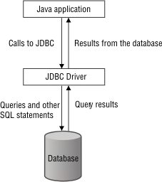

* A Java application calls the JDBC driver, which sends queries and other SQL statements to the database.
* the database sends query results to the JDBC driver,which sends them on to the java application

**✓ Runtime architecture for java applet**

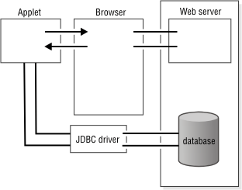

* The database server is connected to the JDBC driver,which is connected to the applet.
* The applet is also connected to the browser,which is connected to a web server that communicates with the database.

**✓ Runtime architecture for java servlet**

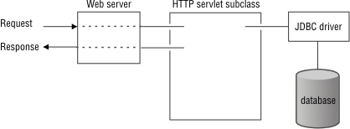

* A request from an application goes through a web server, an HTTP servlet subclass, and the JDBC driver to the database.
* The database sends back responses with the same path.

**4.5. Applet skeleton, Applet Display Methods**

* **Applet skeleton / Applet life cycle :**
* **init( )**
* The init( ) method is the first method to be called.
* This is where you should initialize variables.
* This method is called only once during the run time of your applet.
* **Syntax** :

| public void init( )  {  // initialization  } |
| --- |

* **start( )**
* The start( ) method is called after init( ).
* It is called to restart an applet after it has been stopped.
* start( ) is called each time an applet's document is displayed onscreen.so,if a user leaves a web page and comes back,the applet resumes execution at start( ).
* **Syntax** :

| public void start( )  {  // start or resume execution  } |
| --- |

* **paint( )**
* The paint( ) method is called each time your applet's output must be redrawn.
* **Syntax** :

| public void paint(Graphics g)  {  // Redisplay contents of window  } |
| --- |

* **stop( )**
* The stop( ) method is called when a web browser leaves HTML document containing the applet – when it goes to another page.
* **Syntax** :

| public void stop( )  {  // suspends execution  } |
| --- |

* **destroy ( )**
* The destroy( ) method is called when the environment determines that your applet needs to be removed completely from memory.
* As this point,you should free up any resources the applet may be using.The stop( ) method is always called before distroy( ).
* **Syntax** :

| public void destroy ( )  {  // Perform shutdown activities  } |
| --- |

* **Applet Display Methods :**
* Applets are displayed in a window and they use the awt package to perform input and output functions.
* To output a string to applet,use **drawString( )**,which is a member of **Graphics** class.
* Typically,it is called from within either update( ) or paint( ).
* It has following general form :

| void drawString("Message",int X,int Y ) |
| --- |

* Message - is the string to be output beginning at X and Y.
* **To set color :**
* **setBackground( )** : To set the background color of an applet's window.
* **setForeground( )** : To set the foreground(font) color of an applet's window.
* They have following general form :

| void setBackground (Color.New_color)  void setForeground (Color.New_color) |
| --- |

* Here , new_color specifies the new color.
* The class Color defines the constant shown here that can be used to specify colors.

| Color.black | Color.red |
| --- | --- |
| Color.blue | Color.yellow |
| Color.magenta | Color.green |
| Color.cyan | Color.gray |
| Color.orange | Color.darkGray |
| Color.pink | Color.lightGray |

* **Example :**

|  |  |
| --- | --- |

**4.6. HTML APPLET Tag (<APPLET>), Applet Viewer**

* **HTML APPLET Tag (<APPLET>) :**
* HTML Applet Tag is used to execute an applet using a browser.
* <APPLET> and </APPLET> tags are written in the body section of HTML file.
* It tells the browser ,the name of the Applet to be loaded and the space required.
* An applet viewer will execute each APPLET tag that it finds in a separate window.
* Web browser will allow many applets on a single page.

**4.7. Passing Parameters to Applets**

* APPLET tag in html allows you to pass parameters to an applet.
* <PARAM> tag is used to pass the parameter value from HTML file to APPLET code.
* In the applet source code,applet can refer to the parameter by its NAME to find its VALUE.
* **Syntax for <PARAM> tag :**

| <applet>  <param name="parameter_name" value="parameter_value>  </applet> |
| --- |

* Parameters can be accessed in the applet program using the **getParameter( )** method of the Applet class.
* **getParameter( ) method :**
* The getParameter( ) method of Applet class can be used to retrieve parameters which are passed from the HTML page.
* **Syntax for getParameter( ) method :**

|  |
| --- |

* **J**
* **Example :**

| **JAVA CODE FILE :** | **HTML CODE FILE :** |
| --- | --- |
| **OUTPUT :** | |

**4.8. Shape methods :** (Not In Syllabus)

| **Sr no.** | **Method** | **Description** |
| --- | --- | --- |
| 1 | Line | **Syntax :**  g.drawLine(x1,y1,X2,y2);  **Example :**  g.drawLine(10,20,150,45); |
| 2 | Rectangle | **Syntax :**  g.drawRect(left,top,width,height);  **Example :**  g.drawRect(50,20,100,40); |
| 3 | Ovals | **Syntax :**  g.drawOval(left,top,width,height);  **Example :**  g.drawOval(175,20,50,80); |
| 4 | Arcs | **Syntax :**  g.drawArc(left,top,width,height,start_angle,arc_angle);  **Example :**  g.drawArc(175,20,50,80,0,360); |
| 5 | Polygon | **Syntax :**  g.drawPolygon(X-points,Y-points,points);  **Example :** |
| 6 | Polyline |  |

**4.8. :** (Not In Syllabus)

* **Examples of applet programs :**

**Write a Java Applet to print "simple java applet".**

| **JAVA CODE FILE :** | **HTML CODE FILE :** |
| --- | --- |
| **OUTPUT :** | |

**Write an applet program to display the message “VTU BELGAUM”. Set the background color to cyan and foreground color to red.**

| **JAVA CODE FILE :** | **HTML CODE FILE :** |
| --- | --- |
| **OUTPUT :** | |

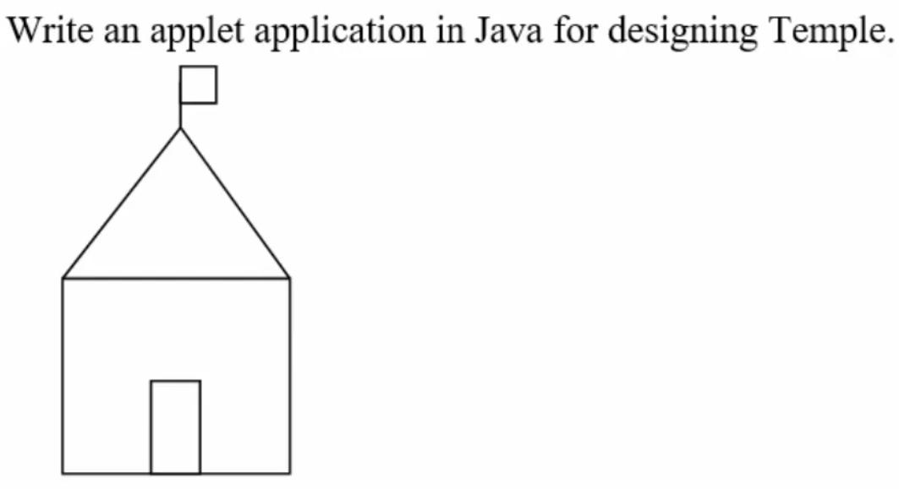

| **JAVA CODE FILE :** | **HTML CODE FILE :** |
| --- | --- |
| **OUTPUT :** | |

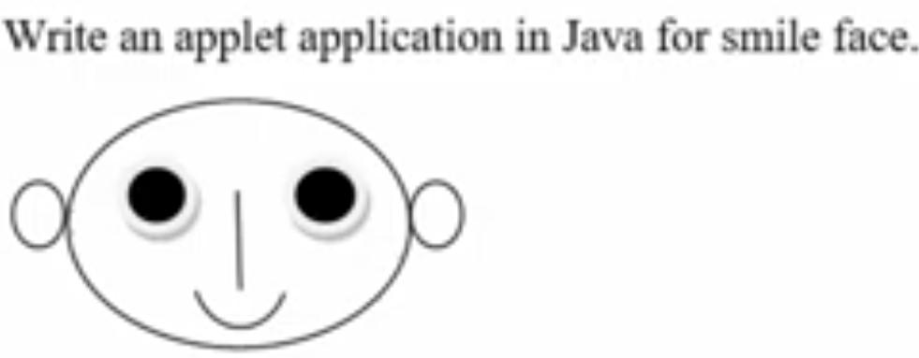

| **JAVA CODE FILE :** | **HTML CODE FILE :** |
| --- | --- |
| **OUTPUT :** | |

**Write an applet application in java for house.**

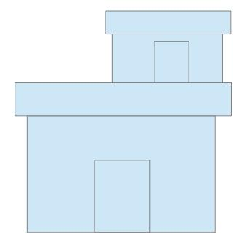

| **JAVA CODE FILE :** | **HTML CODE FILE :** |
| --- | --- |
| **OUTPUT :** | |

**Write an applet application in java for Wind mill**

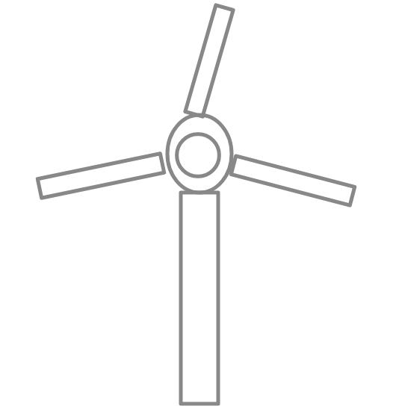

| **JAVA CODE FILE :** | **HTML CODE FILE :** |
| --- | --- |
| **OUTPUT :** | |